Asia Crossword Name: _________________________
Period: ________
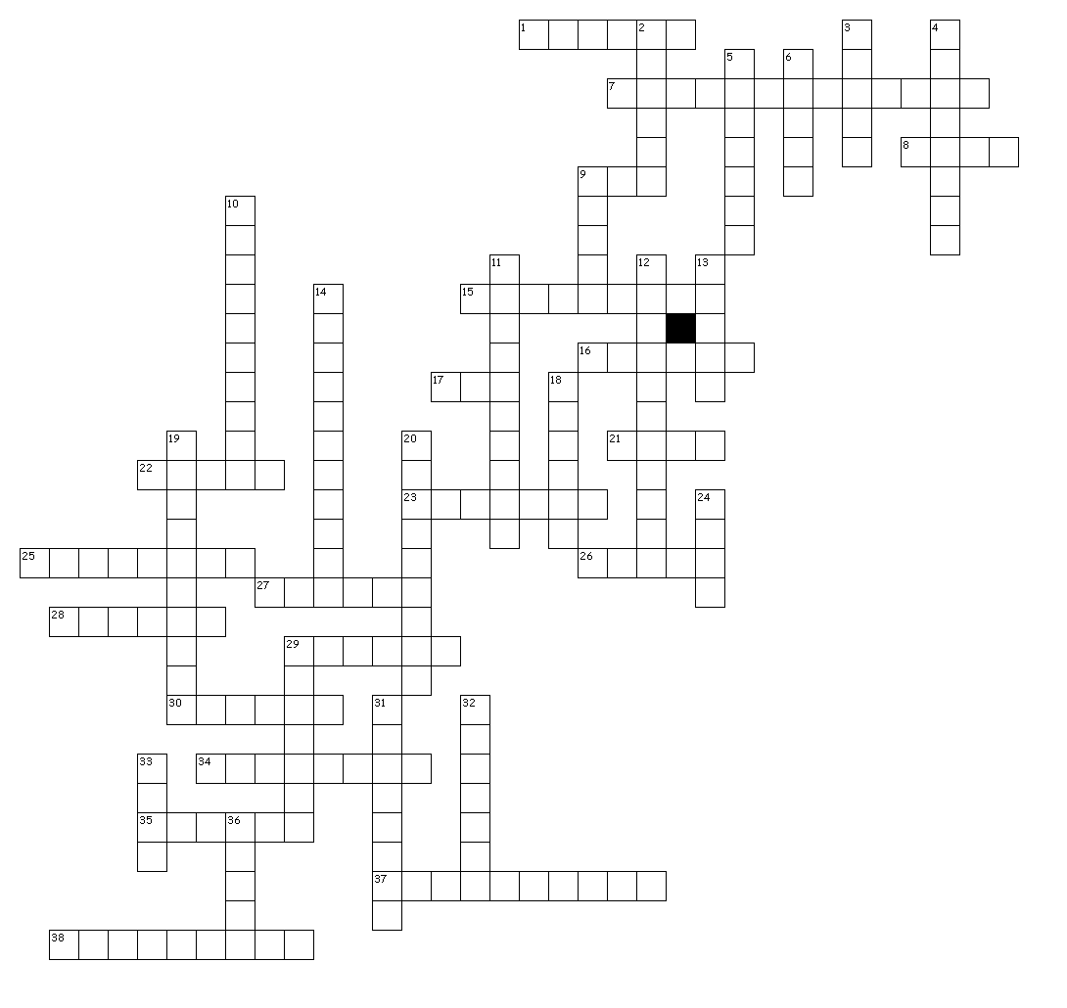

Across

1. Japan’s capital.
7. Name of Russia’s current leader (2015).
8. Indonesia’s capital is on this island.
9. This animal is viewed as a holy symbol in India and wanders the streets unharmed.
15. Tiny country located on the southern most tip of the Malay Peninsula.
16. This island is sometimes referred to as Chinese Taipei.
17. The initials of Russia’s secret police.
21. This type of wrestling is very “big” in Japan.
22. This country divided into a North and a South in the 1950’s.
23. This country is also referred to as Burma.
25. This palace was built in India as a tomb for its leaders wife.
26. This “Giant” black and white bear can only be found in China.
27. Asia’s largest country in terms of land area.
28. The Capital of Russia.
29. This bay is located east of India and is another name for a tiger.
30. This ocean lies to the North of Asia.
34. This country's name means “Land of smiles”.
35. This sea separates Russia from the USA by only 14 miles.
37. Host of the 1988 Summer Olympics and the 2002 Women’s World Cup of Soccer.
38. This feature in China is the only man made object visible from space.

Down

2. This sea separates China and the Korean peninsula.
3. This country is made up of four main islands named Honshu, Hokkaido, Kyushu, and Shikoku.
4. This country is southeast of India.
5. An armed conflict or war that the USA was involved in from approximately 1961 thru 1972.
6. Where Asia ranks in terms of land area and population when compared to the other continents.
9. This country produces 90% of the worlds rice.
10. The name given to the area of the world with more active volcanoes than any other part of the world.
11. Thailand’s national or most popular sport.
12. Russia was called this from 1922-1991.
13. This country is where most climbers attempt to scale Mount Everest.
14. Mindanao and Luzon are two of the islands that make up this archipelago country.
18. Ocean found to the south of Asia.
19. Kim Jong-un is the leader of this country.
20. Mount Everest is found in this Mountain range.
24. These mountains separate Asia from Europe.
29. China’s capital.
31. What religion believes the cow is a religious symbol.
32. The tallest Mount in the world.
33. This desert is located in Northern China and much of Mongolia.
36. Besides China, this country has over one billion people in it.

