Australia Name: _________________________
Period: ________

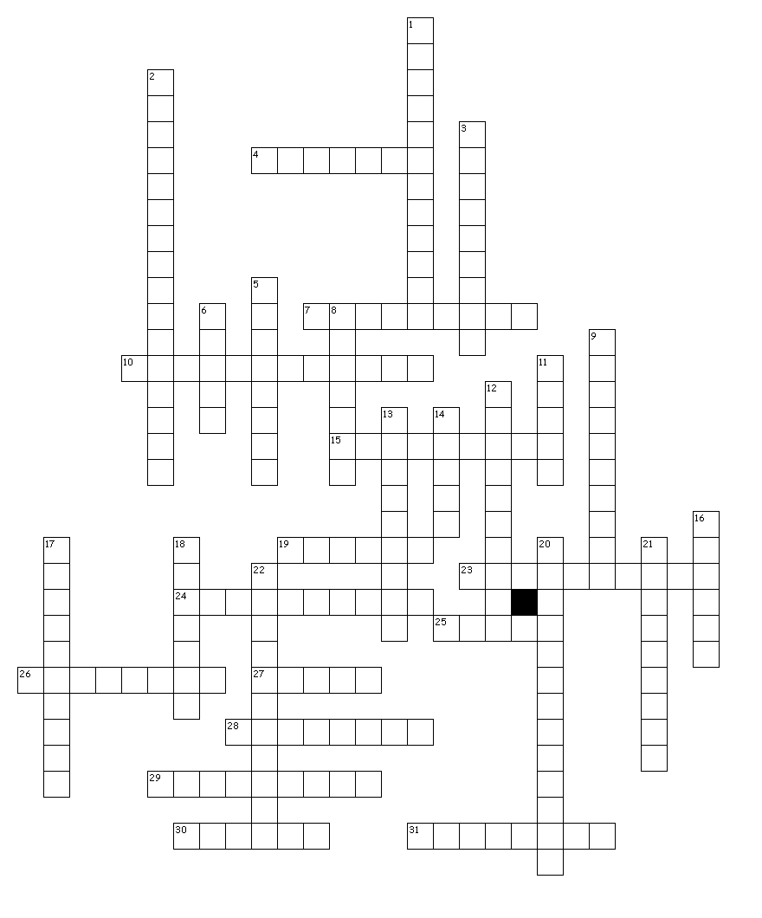
Across

4. Perth is found in this Australian territory, also Australia’s largest.
7. These tools were used as hunting weapons, but today are just cool cause they come back to you
when you throw them.
10. This country colonized Australia.
15. Australia is the only country to occupy one of these.
19. The Opera House is located in what Australian city that hosted the 2000 Summer Olympics.
23. Brisbane is found in this territory.
24. The Great Barrier Reef is the size of what United States state?
25. This large rock holds spiritual meaning to Aborigines and is in the middle of The Outback. 26. This is Australia’s island territory.
27. Australia has this many territories.
28. Melbourne is found in this territory.
29. This city hosted the Summer Olympics in 1956.
30. Australia originally was started as this type of colony.
31. Darwin can be found in this territory.

Down

1. This “Great” mountain range runs along Australia’s East coast.
2. A huge build up of coral of the East coast of Australia.
3. A kangaroo is an example of this, or an animal with a pouch.
5. This city is the capital of Australia.
6. These animals can only be found living in the wild in Australia.
8. The dry desert region located in central Australia.
9. Australia’s original inhabitants.
11. Adelaide is found in this territory.
12. This is one of the most photographed buildings in the world and is in Sydney.
13. This archipelago country is made up of thousands of islands and borders Australia to the
North west.
14. This sea borders Australia to the North and is to the Northwest of the city of Darwin.
16. This ocean borders Australia to the West.
17. This island country is located to the South East of Australia.
18. This ocean borders Australia to the East.
20. Sydney can be found in this territory.
21. This line of latitude runs through Australia.
22. These are possibly the worlds oldest musical instruments.

