Name: ___________________
Period: _____
America Becomes a World Power

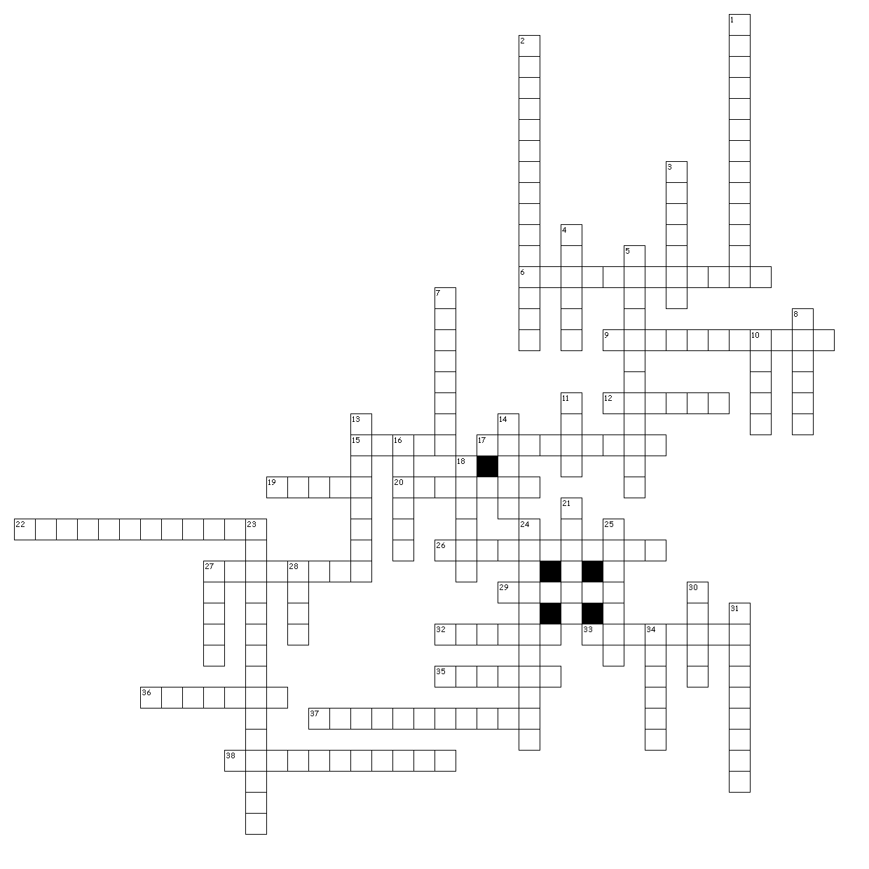

Across

6. Became the Queen of Hawaii after her brother the King died.
9. Name of the volunteer cavalry that Teddy Roosevelt was in.
12. Last name of an American newspaper publisher who built the nation’s largest newspaper
chain.
15. Last name of the Commodore who signed a trade agreement with Japan.
17. Last name of the President who was at the Battle of San Juan Hill.
19. The United States blamed this country for blowing up the USS Maine.
20. This type of influence happens in areas where foreign nations controlled resources.
22. Avoiding involvement in the affairs of other countries. George Washington wanted this. 26. This person was the leader of the Rough Riders and was picked to be the governor of Cuba. 27. Last name of the newspaper publisher who has a major newspaper award named after him.
29. Name of the harbor where the Maine blew up?
32. The act of influencing governments through economic intervention.
33. Last name of the General tasked with catching Pancho Villa.
35. Last name of the person who rid the Panama Canal route of mosquitoes.
36. This disease is contracted by a mosquito bite.
37. Leader of the Mexican rebellion who killed 17 Americans in New Mexico.
38. Building an empire by founding colonies or conquering other nations.

Down

1. The 28th President of the USA and favored the use of the military to dollar diplomacy.
2. This league was opposed to the treaty and creation of an American colonial empire.
3. This Revolution took place in the country that borders the United States to the south.
4. This type of journalism was practiced by Pulitzer and Hearst and often meant exaggerating
the truth.
5. Puerto Rico is one of these that has its own government but is associated to the USA.
7. Last name of the 25th President of the United States. President during the Spanish-American
War.
8. I was the 22nd and 24th President of the United States. (Middle name, same as Sesame
Street character).
10. This Commodore defeated the Spanish in the Philippines.
11. This Doctor was sent to Cuba to help fight Yellow fever. (Last name)
13. This type of policy stated that all nations should have equal access to trade with China. 14. This rebellion pitted Chinese nationalists against foreigners who wanted to trade in
China.
16. Who did the United States buy Alaska from?
18. This amendment stated that the United States had no interest in taking control of Cuba. 21. These islands were annexed by the US in 1867, and were halfway between Japan and the USA. 23. This person was the 13th President of the United States and sent Commodore Perry to Japan. 24. This man made water way cut 7,000 miles off of a ships journey.
25. This act established a civil government in Puerto Rico.
27. This amendment limited Cuba’s right to make treaties and allowed the US to intervene.
28. I was the 27th President of the United States and came up with the idea of dollar
diplomacy.
30. Name of the Battleship that we accused the Spanish of blowing up.
31. Last name of the leader of the Pro-American Filipinos who helped Dewey.
34. Last name of the Secretary of State who bought Alaska.

