Name: __________________________
Period: _____
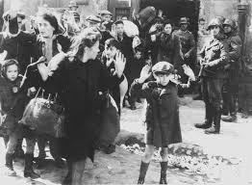

Martin Niemöller (1892-1984) was a prominent Protestant pastor who emerged as an outspoken public foe of Adolf Hitler and spent the last seven years of Nazi rule in concentration camps.
Niemöller is perhaps best remembered for the quotation:
First they came for the Socialists, and I did not speak out--
Because I was not a Socialist.
Then they came for the Trade Unionists, and I did not speak out--
Because I was not a Trade Unionist.
Then they came for the Jews, and I did not speak out--
Because I was not a Jew.
Then they came for me--and there was no one left to speak for me.

The quotation stems from Niemöller's lectures during the early postwar period. Different versions of the quotation exist. These can be attributed to the fact that Niemöller spoke extemporaneously and in a number of settings. Much controversy surrounds the content of the poem as it has been printed in varying forms, referring to diverse groups such as Catholics, Jehovah's Witnesses, Jews, Trade Unionists, or Communists depending upon the version. Nonetheless his point was that Germans--in particular, he believed, the leaders of the Protestant churches--had been complicit through their silence in the Nazi imprisonment, persecution, and murder of millions of people.
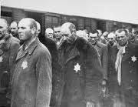

Answer the following questions in full complete sentences.

- Why do you think Niemöller wrote this poem?

- Who is the “They “Niemöller is referring to?

- How can this poem reflect or help describe bullying and what happens with that?

- Describe a situation in your life when you didn’t speak up or chose not to help someone else, and how that made you feel.

