Middle East Crossword Name: __________________________________
Period: ________

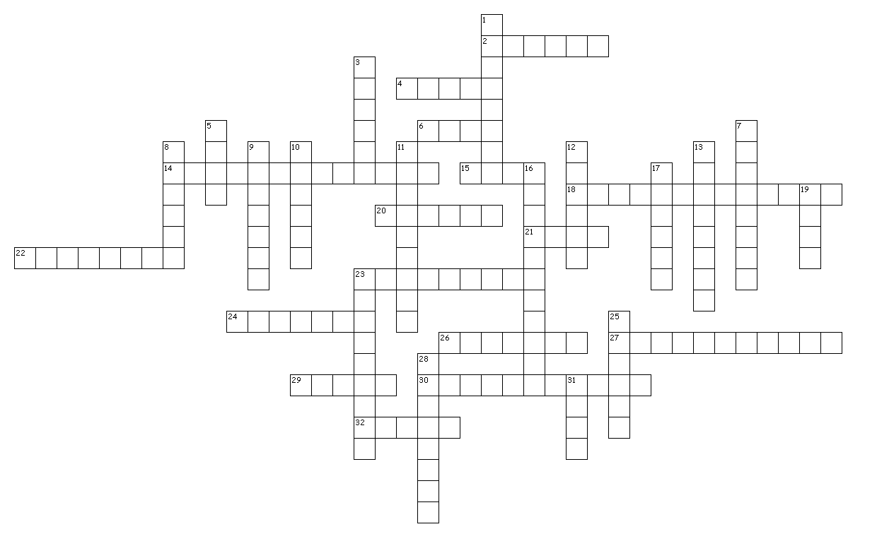

Across

2. 40 North / 33 East (Capital)
4. The most holy city in the Islamic religion.
6. This organization is in charge of oil prices.
14. This terrorist was killed in Pakistan and helped plan the 9/11 attacks.
15. The name of the terrorist group that started in the country of Syria.
18. Former leader of the country of Iraq who was executed.
20. Iraq invaded this country in 1990 thus starting the Gulf War.
21. This country is home to the Tigris and Euphrates rivers and is nicknamed the “Fertile Crescent”.
22. This part of Africa is sometimes considered part of the Middle East due to its religion.
23. The genocide of the Jewish people during WWII.
24. The name of the peninsula that the country of Saudi Arabia sits on.
26. The largest lake in the world is located in the Middle East and is sometimes considered a sea.
27. This country is 95% covered by deserts.
29. An outfit worn by women in Islamic countries that at times covers them from head to toe.
30. This country was ruled by the Taliban and required women to wear “Burkas”.
32. This country is currently involved in a violent civil war that started years ago during the “Arab Spring”.

Down

1. The oldest inhabited city in the world and also the capital of Syria.
3. This sea separates Africa and the Middle East.
5. This sea has such a high salt density that that nothing can live in it.
7. Holy Wars fought to reclaim the “Holy Land”.
8. This river separates Israel from Jordan.
9. This island country is located in the Persian Gulf.
10. 25 North / 46 East (Capital)
11. This city in Israel is claimed by three major religions to be very important.
12. 24 North / 59 East (Capital)
13. 38 North / 58 East (Capital)
16. This former communist country tried to take over Afghanistan in the 1980’s.
17. Last name of the President of The United States when Iran took hostages in the late 1970’s.
19. Tehran is the capital of this country.
23. These mountains border Afghanistan and Pakistan.
25. This country was created as in 1948 as a response to events that took place in WWII.
28. This country apparently looks like a dinosaur according to Mr. Sparling.
31. This word means homeland.

