Name____________
Roaring 1920’s Project
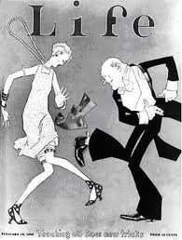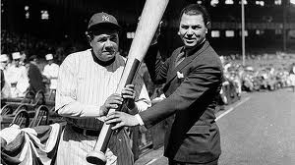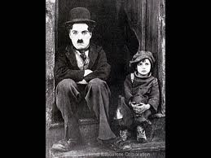
Project: In this project you will be showing the innovations and significant literary, artistic, athletic and political people and events in U.S. History. You will choose a famous 1920’s person and present their biography. You will present this person’s life story including their impact on the United States.

Requirements:

- Presentation must be a Google Doc, Prezi, or poster.

- Person’s life, especially what they are famous for and their impact on the US.

- Pictures of your person. Pictures of any inventions or why they are famous.

- You should become an expert on this person and be able to tell me basic facts about their life.

- You are responsible for a 4-6 minute class presentation

Extra points will be given for:
- The inclusion of video in any project.
- Dressing up like your character for the presentation. (All outfits must be approved prior to day of presentation)

Possible People To Research:

Athletes: Entertainers: Presidents:
- Gene Tunney- Boxer - Bessie Smith- Singer - Wilson
- Babe Ruth- Baseball - Georgia O’Keeffe- Painter - Harding
- Helen Wills- Tennis - Louis Armstrong- Musician - Coolidge
- Andrew “Rube” Foster- Baseball - “Duke” Ellington- Musician - Hoover
- Gertrude Ederle- Swimmer - George Gershwin- Composer
- Jack Dempsey- Boxer - Rudolph Valentino- Dancer Authors:
- Ty Cobb- Baseball - Walt Disney- Cartoonist - Zelda Fitzgerald
- Jim Thorpe- Football - Joan Crawford- Dancer - F. Scott Fitzgerald
- Lou Gehrig- Baseball - Bing Crosby- Singer - Ernest Hemingway
- Glenna Collett- Golf - Charlie Chaplin- Actor -Claude McKay
- Satchel Paige - Josephine Baker- Actress - Langston Hughes

Other:

- Al Capone- Gangster
- Flappers - Bootleggers - Henry Ford- Business Man
- Charles Lindbergh- Pilot -Amelia Earhart- Pilot - John T. Scoops- Teacher -

* Only one person per class.

My person will be: ____________________________________________ Teacher approved: ________________________________________

Presentations will be on: ____________________________________________

