World War II
Name: _____________________________
Period: ____
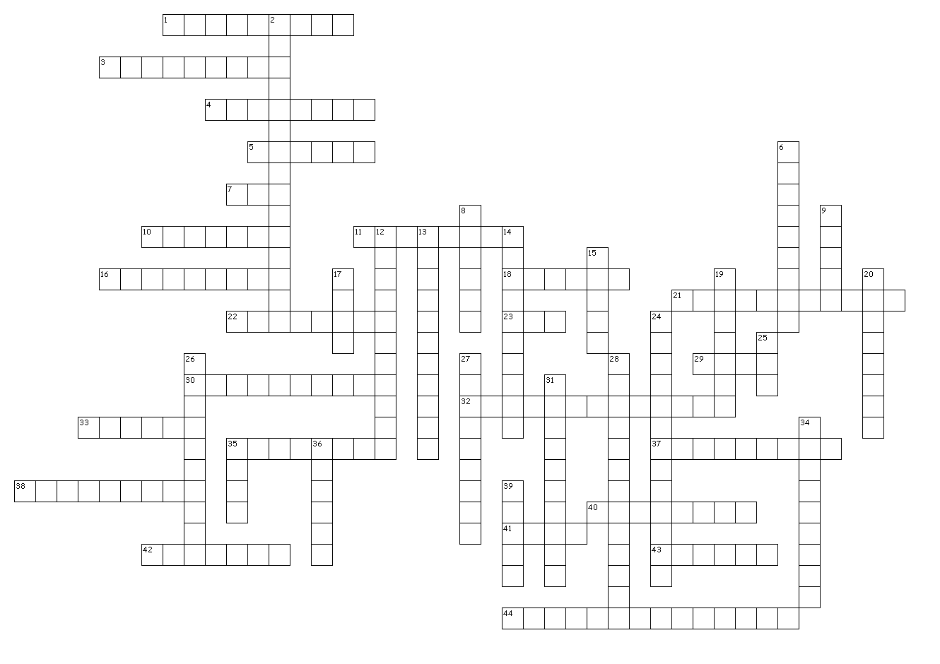
Across

1. This General in the Pacific vowed to return to the Philippines.
3. Blaming someone else for your downfalls.
4. Name of the plane that dropped the first Atomic bomb.
5. Leader of the Soviet Union.
7. The 32 President of the USA.
10. This ship serves as a monument in Pearl Harbor and was sunk by the Japanese.
11. The second Atomic bomb was dropped here.
16. I was the dictator of Italy.
18. This person took over for FDR when he died in office.
21. This cook was famous for his bravery at Pearl Harbor.
22. Japanese suicide pilots.
23. Royal Air Force (Acronym)
29. Acronym for Women Air Service Pilots.
30. This US General in Europe went on to become the President of the USA.
32. The name of Hitler’s plan to eliminate the Jewish people.
33. German submarines.
35. The site of the D-Day Invasion.
37. Nickname given to the first Atomic bomb dropped on Hiroshima.
38. British Admiral who later took over as their Prime Minister.
40. The USA first stopped the Japanese at the Naval Battle of The ______ ____ of the coast of Australia.
41. This Alliance was made up of Germany, Italy, and Japan.
42. A political system in which the “state” or government is seen as more important than individuals.
43. This person rose to power in Germany and wanted a “Final Solution”.
44. A squadron of African American pilots who fought in the Pacific during WWII.

Down

2. A political system in which the government controls every aspect of citizens’ lives.
6. The first Atomic bomb was dropped on this city.
8. Code talkers for the Americans in WWII belonged to this Native American group.
9. Harbor Surprise attack on December 7th, 1941.
12. The most decorated American soldier of WWII.
13. A policy of avoiding war with an aggressive nation by giving in to its demands.
14. The forced relocation of thousands of Japanese Americans.
15. Capital of France.
17. June 6th, 1944
19. This was Hitler’s first failure, The Battle of ____________.
20. The extermination of an entire group or race of people.
24. The night of broken glass.
25. This board was to oversee the conversion of factories to war production.
26. Hitler blamed this treaty that ended WWI for part of Germany’s problems.
27. German Air force.
28. The strategy of attacking the most strategic Japanese held islands and isolating the smaller ones.
31. Lightning warfare.
34. The murder of 6,000,000 Jewish people became known as the _______________.
35. The name of Adolf Hitler’s political party.
36. This Alliance was made up of the USA, Britain, France, and the Soviet Union.
39. The most fierce fighting of the D-Day invasion took place on this beach.

